Honorable Council Members
City of Woodstock, IL
Expansion of Super Aggregates Facility

Thank you for taking the time to hear my opposition to the proposed expansion of the Super Aggregates facility which borders Route 14, Lily Pond Road, and McConnell Road. As a resident and concerned citizen of Woodstock, IL, I believe that safe, secure, and hazard free neighborhoods embody the socio-economic beauty which attracts individuals and families to this great community. Without understanding and creating a community that embraces its pure legacy dating back to 1852, we become nothing more than a geographical location on a map.
From the Historic Square to the open spaces which provide a unique departure from other points of interest in this great state of Illinois, Woodstock creates an environment rich in diversity, beauty, kinship, and solitude. The backbone of this City falls squarely upon families who raise and nurture future generations who are proud of sustainable developments and progress which do not alter its image and landscape. We are the talent and treasure that uniquely equates to Woodstock, IL.
What is at stake if expansion is allowed:
1). Disruption and potential contamination of the abundant fens in our community to naturally process clean water flow, clarity, and water budget for those who rely on its daily use. (Report January 12, 2026 – Lake Woodstock Development Analysis, University of Illinois Urbana Champaign, Erik T. Plankell, Assoc. Research Scientist; Randall A. Locke, Chief Scientist- Review of Illinois Nature Preserve Defense Specialist Valerie Njapa Defense Specialist- Effect on Ground Water specific to Fens and soil disruption.)

2). Air Quality Impact. Aggregate mining near residential areas can significantly degrade air quality, with documented increases in fine particulate matter (PM 2.5) and coarse particulate matter (PM 10) that exceed national and WHO safety thresholds, especially during peak traffic hours.
(Mineral Products Association: MPA_Quarries_and_Dust_Air_Emissions_2022.pdf)

3). Housing Values. Properties near aggregate mining sites in Chicago have historically experienced significant value declines — sometimes up to 25% or more — due to noise, dust, and environmental impacts, even if the owner never sells.
Example from Senate Correspondence circa September 29, 2008, brought into debate. (Stoneco Gravel Mine Richland Township, Virgina)

IMPACT OF QUARRIES ON PROPERTY VALUES (Chart):

THE DISTANCE FROM QUARRY LOWERS HOME VALUES PROPORTIONATELY:
- 0-.31 MILES HOME VALUES DROPPED 25% OR MORE
- .625 MILES HOME VALUES DROPPED 15-20%
- 1 MILE HOMES VALUES DROPPED JUST UNDER 15%
- 1.25-2 MILES HOME VALUES DROPPED JUST UNDER 10%
- 2.5-3.1 MILES HOME VALUES DROPPED 5-7%

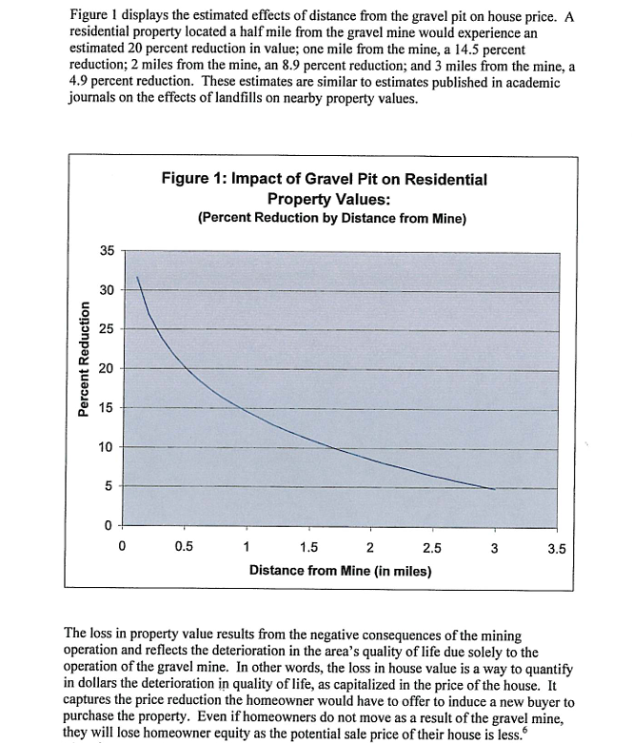

Why home values drop: citizensagainstminig.org
Quarries can reduce property values through:
- Noise and dust from blasting, crushing, and truck traffic.
- Increased truck traffic that can damage roads and raise long-term maintenance costs.
- Environmental impacts such as reduced water table levels, altered drainage, and potential groundwater contamination.
- Perceived loss of desirability for the neighborhood, leading to reduced sales and population density.

5). Residential health risks for residents. (fractracker.org)
Why expand a Gravel Pit / mining operation that creates a known carcinogen (cancer-causing) right next to homes.

This is not an exhaustive list of reasons to halt expansion of the proposed mining operation in Woodstock, IL, which Super Aggregates proposes, but voices extreme concern from your constituents. With a clear voice, we say listen to those who see a dynamic shift in not only our lives, but what Woodstock should continue to be – free from encroachment of quarries and all other entities which can and will compromise our liberties protected by our inalienable rights.
Sincerely,
[Insert Name Here]

